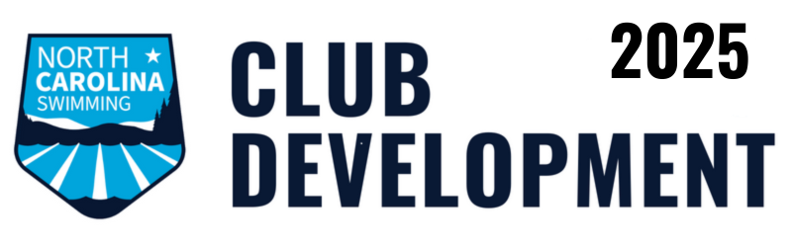
Qualifying Period: September 1, 2024 to August 31, 2025 Online submission deadline: October 15, 2025
$2/point - $50 per line item max (except as noted) - $1,000 per team max
SWIMMER ENGAGEMENT | POINTS | SWIMMER DEVELOPMENT | POINTS
# First time USA Swimming members joining the team |  | # Swimmers who were first time qualifiers for an NCS Championship Meet
% of membership retention from prior year |  | # Swimmers who qualified for at least one NCS Championship Meet
# First time participants in a sanctioned or approved YMCA meet |  | # Swimmers who qualified an NCS Championship Meet in each IMX event for their age group
# First time participants in a sanctioned or approved YMCA long course meet |  | # Swimmers who qualified for an NCS Championships Meet in the 400M/Y IM
# Swimmers competing in at least four sanctioned or approved YMCA meets |  | # Swimmers who qualified for an NCS Championship Meet in the 800M/1000Y/1500M/1650Y Free
# Swimmers participating in a USA Swimming or NCS Camp/Clinic |  | # Swimmers who competed in Carolina Crown
# Swimmers who attended an NCS HOD meeting or Spring Workshop |  | # Swimmers whose fastest times qualified them for a Nationals/US Open meet
# Swimmers who served on the NCS Board, a committee, or taskforce |  | # Other swimmers whose fastest times qualified them for a Junior Nationals meet
# Swimmers with at least a BB time in any event |  | # Other swimmers whose fastest times qualified them for Futures
# Swimmers with IMR Scores |  | # Other swimmers whose fastest times qualified them for ESSZ Sectionals
# Swimmers with IMX Scores |  | # Swimmers who competed in a sanctioned Open Water Meet for the first time
COACH DEVELOPMENT |  | # Swimmers who competed in NCS Open Water Championships
# Coaches who attended a coaching clinic (ASCA, NCS, USA Swimming) |  | # Swimmers who competed in Open Water Zones
# Coaches who are ASCA certified |  | # Swimmers who competed in Open Water Nationals
# Coaches who serve on an NCS team or camp coaching staff (add 25 points per coach)

# Coaches who coached for another competitive swim team (summer league, high school, college) other than their USA/NCS team or provided a clinic |  | CLUB DEVELOPMENT AND MANAGEMENT
# Coaches who attended Fall HOD as voting members |  | Does your club communicate on social media? If so, add 10 points.
VOLUNTEER DEVELOPMENT |  | Does your club follow NC Swimming on Instagram or Facebook? If so add 25 points.
# New Stroke & Turn and Administrative Officials who worked more than 6 sessions |  | Is your head coach signed up via Mail Poet to receive NCS email updates? If so add 25 points.
# Officials who worked more than 4 sessions |  | Is your head coach signed up to receive NCS Gmail updates? If so, add 25 points.
# Officials who worked more than 4 sessions at one NCS Championship, Tar Heel States, or B/C Champs |  | Was your club Safe Sport Recognized on 8/31/2025? If so, add 250 points.
# Officials who received an N2 or N3 evaluation at any OQM |  | Did your club earn Club Excellence recognition as Bronze, Silver, or Gold in 2024/2025? If so, add 50 points.
# NCS sanctioned meets hosted open to any NCS team (not closed, intra, dual, tri, or quad) (add 25 points per meet) |  | If your club renewed 2025 NCS club registration and head coach membership by 12/1/24, add 25 points OR
# NCS sanctioned or approved meets hosted (add 10 points per meet) |  | If your club renewed 2025 NCS club registration and head coach membership by 12/15/24, add 5 points.
# First time parent volunteers at a hosted meet |  | If your club renewed all full-time coach 2025 memberships by 12/1/24, add 5 points per coach OR
COMMUNITY ENGAGEMENT |  | If your club renewed all full-time coach 2025 memberships by 12/15/24, add 1 point per coach
% Swimmers who participated in a team endorsed public service event (swim-a-thon, food drive, walk/run, etc.) |  | If your club reimbursed or paid for Officials’ 2025 USA Swimming membership fees, add 5 points per Official.
# Outreach memberships |  | If you named an NCS Club Athlete representative, add 5 points
# Outreach members who participated in an NCS sanctioned meet |  | If a coach, athlete, official, or parent from your club serves as an NCS Board of Directors of NCS committee member, add 25 points per person
# Swimmers who were named in 9/2024 as USA Swimming Scholastic All-Americans

