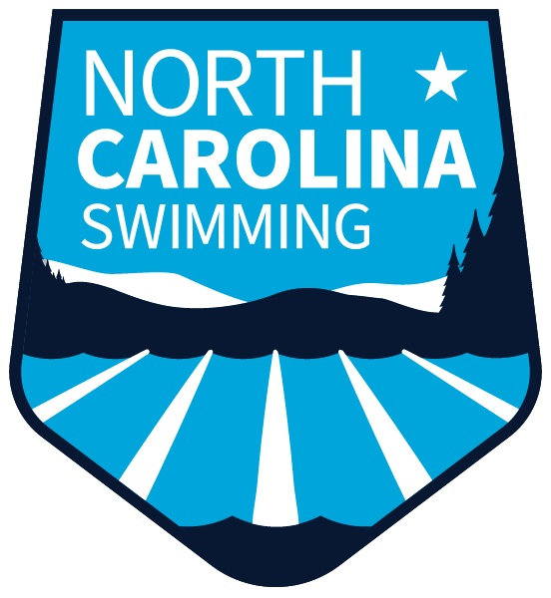
Leading the nation in development, diversity, achievement, and citizenship, in and out of the water
Enriching the competitive swimming experience in North Carolina with resources, programming, and leadership

MEETING AGENDA
Fall House of Delegates
Sunday, October 1, 2023
Raleigh, NC

- Call to Order – Trish Martin

- Roll Call/Delegate Count – Linda Hughes/Barb Frith

- Reading, correction, and adoption of minutes – Linda Hughes

- BOD Reports
  - General Chair – Trish Martin
  - Treasurer – Jon Fox
  - Scheduling– Kevin Thornton for approval of 2023 LC meet schedule
  - Operations– Jon Jolley
  - Programs– Jonathan Watson
  - Athletes– Andy Cummins
  - Officials– John Jewell
  - DEI– Jamie Bloom
  - Safe Sport– Mike Trexler

- Swims 3.0 Update – Barb Frith

- Board of Directors Elections – Chris Hoover/Wayne Shulby

- Legislation – Wayne Shulby

- Old Business

- New Business

- Coaches Education Raffle

- Next meeting: October 6, 2024

- Adjournment of the House of Delegates

- Meeting of New Board of Directors Members

